CUSTOMER SEGMENTATION USING DATA MINING
A Project-Based Report
Big Data Analytics (23DSB3303R)
Submitted in partial fulfillment of the requirements for the award of the degree of

BACHELOR OF TECHNOLOGY
In

COMPUTER SCIENCE AND ENGINEERING
By
Geetha Ganta (2320030487)
Nikhitha Vedantam (2320030075)
Nishitha Vedantam (2320030076)

Under the Guidance of
Dr. Krishna Kishore
Associate Professor


DEPARTMENT OF COMPUTER SCIENCE AND ENGINEERING
KONERU LAKSHMAIAH EDUCATION FOUNDATION
(DEEMED TO BE UNIVERSITY)
BOWRAMPET, HYDERABAD-500043, TELANGANA, INDIA.

ACADEMIC YEAR: 2025-2026

DECLARATION

The Project-Based Report Data Warehouse and mining (23DSB3303R) entitled “Customer Segmentation using data mining ” is a record of bonafide work of Geetha Ganta(2320030487) , Nikhitha Vedantam (2320030075), Nishitha Vedantam (2320030076) submitted in partial fulfillment of the requirements for the award of B. Tech in Computer Science and Engineering to the Koneru Lakshmaiah Education Foundation. The results embodied in this report have not been copied from any other department/University, /Institute.

Geetha. G (2320030487)
Nikhitha. V (2320030075)
Nishitha. V (2320030076)

CERTIFICATE

This is to certify that the project-based report Data warehouse and mining (23DSB3303R) entitled “Customer segmentation using machine learning and data mining” is bonafide work done and submitted by Geetha.G(2320030487), Nikhitha.V (2320030075), Nishitha.V (2320030076).i partial fulfillment of the requirements for the award of the degree of BACHELOR OF TECHNOLOGY in the Department of Computer Science and Engineering, Koneru Lakshmaiah Education Foundation, during the academic year 2025-2026.

Guide HOD
Dr.Krishna kishore Dr. Venkateswara Rao Pulipati
Associate Professor Associate Professor
Dept. of CSE Dept. of CSE

ACKNOWLEDGEMENT

With great pleasure, we want to take this opportunity to express our heartfelt gratitude to all the people who helped in making this project a grand success.
We are grateful to Dr. Krishna Kishore, Associate Professor, Department of Computer Science and Engineering, for his valuable technical suggestions and guidance during the execution of this project work.
We want to thank Dr. Venkateswara Rao Pulipati, Professor, Head of the Department of Computer Science and Engineering, Koneru Lakshmaiah Education Foundation, who is the primary driving force behind completing our project work successfully.
We are highly indebted to Dr.L Koteswara Rao, Principal, Koneru Lakshmaiah Education Foundation, for permitting us to carry out this project in a successful and fruitful way.
We want to thank the Teaching & Non- teaching staff of the Department of Artificial Intelligence and Data Science for their cooperation.
Finally, we thank our parents, who have stood behind us at different project stages. We sincerely acknowledge and thank those who directly and indirectly support completing this project.

Geetha.G 2320030487
Nikhitha.V 2320030075
Nishitha.V 2320030076

1 |  | INTRODUCTION | 7
 |  | 1.1 Problem Statement | 7
 |  | 1.2 Research Objective | 7
 |  | 1.3 Project Scope and Limitations | 7
2 |  | BACKGROUND WORK | 8
 |  | 2.1 Logistic Regression | 8
 |  | 2.1.1 Introduction | 8
 |  | 2.1.2 Merits, Demerits and Challenges | 8
 |  | 2.1.3 Implementation of Logistic Regression | 9
 |  | 2.2 Random Forest | 10
 |  | 2.2.1 Introduction | 10
 |  | 2.2.2 Merits, Demerits and Challenges | 10
 |  | 2.2.3 Implementation of Random Forest | 11
 |  | 2.3 Isolation Forest | 12
 |  | 2.3.1 Introduction | 12
 |  | 2.3.2 Merits, Demerits and Challenges | 12
 |  | 2.3.3 Implementation of Isolation Forest | 13
3 |  | PROPOSED SYSTEM | 14
 |  | 3.1 Objective of Proposed Model | 14
 |  | 3.2 Algorithms Used for Proposed Model | 14
 |  | 3.3 Designing | 15
 |  | 3.3.1 UML Diagram | 16
 |  | 3.3.2 Stepwise Implementation | 17,18
 |  | Code | 19
4 |  | RESULTS AND DISCUSSION | 21
 |  | 4.1 Performance Metrics | 22
5 |  | CONCLUSIONS | 25
 |  | 5.1 Conclusion and Future Enhancement | 26
6 |  | REFERENCES | 26
7 |  | GitHub Link | 27

ABSTRACT

Customer segmentation using data mining

Customer segmentation is a crucial technique in data analytics that enables businesses to divide customers into meaningful groups based on shared characteristics such as income, age, and spending behavior. In today’s data-driven world, organizations collect vast amounts of customer data, but without proper analysis, this data remains underutilized.
This project presents a machine learning-based approach to customer segmentation using clustering techniques. The dataset is first preprocessed by handling missing values, normalizing features, and selecting relevant attributes. The K-Means clustering algorithm is applied to group customers based on similarity.
The optimal number of clusters is determined using the Elbow Method. Visualization techniques such as scatter plots are used to interpret cluster behavior. The results identify different customer groups like high-value customers, average spenders, and low-income customers.
The proposed system helps businesses improve marketing strategies, personalize services, and enhance customer satisfaction. This project demonstrates the effectiveness of machine learning in extracting actionable insights from customer data.

CHAPTER 1
INTRODUCTION

  - Problem Statement
In the modern digital world, businesses collect large amounts of customer data, but analyzing this data effectively is a major challenge. Without proper segmentation, companies treat all customers the same, which leads to inefficient marketing and poor decision-making.
Customer behavior varies based on factors like income, age, and spending habits, making it necessary to divide customers into meaningful groups. Manual segmentation is not practical for large datasets.This project addresses the problem by using machine learning techniques to automatically group customers based on similarity, helping businesses better understand and target their audience.

  - Research Objective
The main objective of this project is to develop a system that segments customers into different groups using clustering algorithms. By analyzing customer attributes, the system identifies patterns in behavior and categorizes customers accordingly.Another objective is to help businesses make better decisions by understanding customer preferences and spending patterns. This enables targeted marketing strategies and improved customer satisfaction.

  - Project Scope and Limitations
The scope of this project includes analyzing customer data and applying clustering techniques to identify meaningful segments. It is useful for businesses to understand customer behavior and improve marketing strategies.However, the project has certain limitations. It works only with structured datasets and does not support real-time data processing. Additionally, the K-Means algorithm assumes clusters of similar shapes, which may not always represent real-world data accurately.

CHAPTER 2
BACKGROUND WORK

2.1 K-Means Clustering

2.1.1 Introduction
K-Means clustering is one of the most widely used unsupervised machine learning algorithms for grouping data into clusters based on similarity. In customer segmentation, it helps in dividing customers into different groups based on features such as income, age, and spending score.The algorithm works by selecting a predefined number of clusters (K) and assigning each data point to the nearest cluster center (centroid). It then updates the centroids iteratively until the clusters become stable.K-Means is preferred in this project because it is simple to implement, computationally efficient, and provides clear segmentation results that are easy to interpret

2.1.2 Merits, Demerits, and Challenges

Merits
K-Means is easy to understand and implement, making it suitable for beginners and real-world applications. It works efficiently even with large datasets and provides fast results. The output clusters are easy to visualize and interpret, which is helpful in business analysis

Demerits
The algorithm requires specifying the number of clusters (K) in advance, which is not always obvious. It is also sensitive to outliers, which can distort cluster formation. Additionally, it assumes that clusters are spherical and evenly sized, which may not always match real-world data.

Challenges
Choosing the optimal number of clusters is a key challenge in K-Means. Improper selection of K can lead to poor segmentation. Another challenge is feature scaling, as differences in data range can affect clustering accuracy.

2.1.3 Implementation of K-means clustering
In this project, K-Means is applied to customer data after preprocessing. The dataset is cleaned, normalized, and relevant features such as annual income and spending score are selected.
The algorithm is then trained using different values of K, and the optimal number of clusters is determined using the Elbow Method. After clustering, each customer is assigned to a group, and the results are visualized using scatter plots.
The final clusters represent different types of customers, such as high spenders, low spenders, and average customers.
2.2 Hierarchical Clustering

2.2.1 Introduction
Hierarchical clustering is an unsupervised machine learning technique used to group data points into clusters based on their similarity. Unlike K-Means clustering, it does not require the number of clusters to be specified in advance. Instead, it builds a hierarchy of clusters in a step-by-step manner, which can be represented using a tree-like structure called a dendrogram.
There are two main approaches in hierarchical clustering: agglomerative and divisive. Agglomerative clustering starts with each data point as an individual cluster and gradually merges them based on similarity, while divisive clustering starts with all data points in a single cluster and splits them into smaller groups.
This method is useful for understanding the natural grouping and relationships within the dataset. In customer segmentation, hierarchical clustering helps visualize how customers are related to each other based on features such as income and spending behavior, making it easier to identify meaningful patterns in the data.

2.2.2 Merits, Demerits, and Challenges

Merits
Hierarchical clustering does not require the number of clusters to be specified in advance, which makes it flexible for exploratory data analysis. It provides a clear visual representation of data through a dendrogram, helping to understand the relationships between different data points.
The method is useful for identifying natural groupings in the dataset and works well for smaller datasets. It also allows easy interpretation of how clusters are formed step by step.

Demerits
Hierarchical clustering is computationally expensive and not suitable for large datasets due to high time and memory requirements. Once clusters are formed, they cannot be modified easily, making the process less flexible compared to other algorithms.
Additionally, the results can be sensitive to noise and outliers, which may affect the overall clustering structure.

Challenges
One of the main challenges is determining the correct level at which the dendrogram should be cut to form clusters. Selecting this level incorrectly can lead to poor segmentation.
Another challenge is handling large datasets efficiently, as the algorithm becomes slow with increasing data size. Proper preprocessing and feature selection are also required to improve clustering accuracy.

2.2.3 Implementation of Customer segmentation(k-means)
In this project, K-Means clustering is implemented as the primary model to perform customer segmentation. The dataset is first pre-processed by cleaning missing values, normalizing numerical features, and selecting relevant attributes such as age, annual income, and spending score. The processed data is then prepared for clustering.
The K-Means algorithm is applied by selecting an appropriate number of clusters using the Elbow Method. The model iteratively assigns customers to clusters based on similarity and updates the cluster centroids until stable groups are formed.
During prediction, each customer is assigned to a cluster that represents a specific behavior pattern. The clusters are analyzed to understand customer categories such as high-value customers, low spenders, and average customers.
The results show that K-Means provides clear and interpretable segmentation, making it an effective technique for customer analysis and targeted marketing strategies.
2.3 DBSCAN
2.3.1 Introduction
DBSCAN is a density-based clustering algorithm used to group data points based on the density of data in a given region. Unlike K-Means, it does not require specifying the number of clusters beforehand.
The algorithm identifies clusters as areas with a high concentration of data points, while points in low-density regions are treated as noise. This makes it useful for detecting irregular patterns in data.
In customer segmentation, DBSCAN can help identify unusual customer behavior and separate outliers from normal customer groups.

2.3.2 Merits, Demerits, and Challenges

Merits

One of the major advantages of DBSCAN is its ability to detect clusters of arbitrary shapes, which makes it suitable for real-world data. It does not require specifying the number of clusters in advance, providing flexibility in analysis.

It is also effective in handling noise and outliers, which improves the quality of segmentation results.

Demerits

DBSCAN requires careful tuning of parameters such as epsilon and minimum points. Incorrect parameter values can lead to poor clustering results.

It may also struggle when the dataset contains clusters with varying densities.

Challenges
Selecting appropriate parameter values is a major challenge and directly affects clustering accuracy. Improper selection can lead to incorrect grouping of customers.
Another challenge is handling high-dimensional data, where performance may decrease without proper preprocessing.

2.3.3 Implementation of DBSCAN
In this project, DBSCAN (Density-Based Spatial Clustering of Applications with Noise) is implemented as an alternative clustering technique to analyze customer data and identify hidden patterns. Unlike traditional clustering algorithms, DBSCAN groups data points based on the density of data in a given region, making it suitable for identifying irregular patterns and outliers in customer behavior.
The implementation begins with data preprocessing, which includes handling missing values, removing duplicate records, and scaling numerical features such as annual income and spending score. Feature scaling is an important step because DBSCAN relies on distance calculations, and inconsistent data ranges can affect clustering results. Once the dataset is cleaned and normalized, it is ready for clustering.
DBSCAN works by selecting two key parameters: epsilon (ε), which defines the neighborhood radius, and the minimum number of points required to form a dense region. Based on these parameters, the algorithm scans the dataset and groups customers into clusters where data points are closely packed together. Points that do not belong to any dense region are treated as noise or outliers.
During execution, the algorithm identifies core points, border points, and noise points. Core points belong to dense regions and form the main clusters, while border points lie near cluster boundaries. Noise points represent unusual or rare customer behavior, which can be useful for identifying unique or unexpected patterns in customer data.
The clustering results obtained from DBSCAN are then analyzed and compared with the results from K-Means clustering. While K-Means provides clear and well-defined clusters, DBSCAN offers additional insights by identifying outliers and non-uniform cluster shapes. This makes DBSCAN particularly useful in understanding complex customer behavior that may not follow regular patterns.
Overall, DBSCAN enhances the segmentation process by providing a density-based perspective of customer data. It complements K-Means clustering by detecting irregular patterns and highlighting unusual customer groups, making it a valuable component in the customer segmentation system.

CHAPTER 3
PROPOSED SYSTEM

3.1 Objective of Proposed Model

The main goal of the proposed system is to develop an efficient and scalable customer segmentation model using data warehousing and machine learning techniques. With the increasing volume of customer data, there is a need for systems that can store, process, and analyze large datasets effectively.
The system focuses on analyzing customer data stored in a data warehouse and identifying meaningful segments based on behavior and attributes. The objective is to improve decision-making by providing insights into customer preferences.
Another goal is to enhance marketing strategies by identifying high-value customers and potential target groups. The system is also designed to handle large datasets efficiently and provide accurate segmentation results.

3.2 Algorithms Used for Proposed Model

The customer segmentation system is designed using machine learning algorithms that help analyze customer data and identify patterns.
K-Means clustering is used as the primary algorithm to group customers based on similarity. It helps in identifying distinct customer segments.
DBSCAN is used as an alternative method to detect outliers and irregular patterns in the dataset.
By combining these approaches, the system provides a more comprehensive understanding of customer behavior.

3.3 Designing
The system follows a structured pipeline approach to ensure efficient data processing and accurate segmentation.
The first component is the data warehouse, where customer data is stored in a structured format. This allows efficient data retrieval and management.
The data is then passed to the preprocessing module, where cleaning and transformation operations are performed. The next stage is feature selection, where relevant attributes are selected for clustering.
The processed data is then fed into the machine learning models, where clustering algorithms are applied. Finally, the results are visualized and analyzed to understand customer segments.
This design ensures scalability and efficient handling of large datasets.

3.3.1 UML Diagram
The UML diagram represents the flow of the customer segmentation system. It shows how data moves from the input stage to the final output.
The system starts with data collection, followed by preprocessing and feature selection. The processed data is then passed to clustering algorithms, and the results are generated.
The diagram helps in understanding the workflow and interaction between different components of the system.

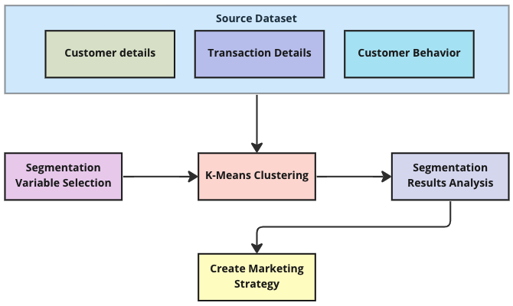

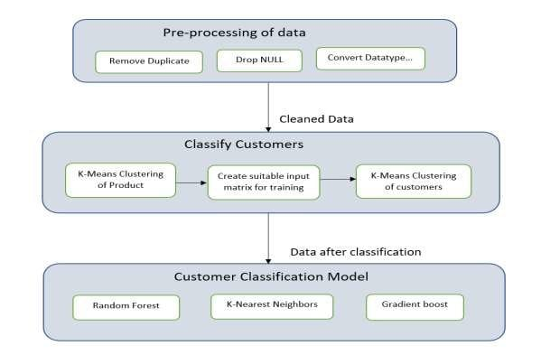

3.3.2 Stepwise Implementation and Code

The implementation of the customer segmentation system is carried out through a structured and systematic pipeline. Each stage plays an important role in transforming raw customer data into meaningful clusters that help in understanding customer behavior. The process ensures accuracy, efficiency, and scalability in handling large datasets.

Step 1: Data Collection and Data Warehousing
The first step in the implementation process is data collection, where customer-related data is gathered from various sources such as transactional systems, CRM tools, or publicly available datasets. The dataset typically contains attributes such as Customer ID, Age, Annual Income, and Spending Score.To efficiently manage large volumes of data, the collected data is stored in a data warehouse. A data warehouse allows structured storage, easy retrieval, and integration of data from multiple sources. It ensures that the data is organized and ready for analysis.
The dataset is usually stored in formats such as CSV or database tables and is loaded into the working environment using tools like Python (Pandas). This step ensures that all relevant data is available for further processing.

Step 2: Data Preprocessing
Data preprocessing is one of the most critical steps in the pipeline, as real-world data is often incomplete, inconsistent, and noisy. The goal of this step is to clean and prepare the data for analysis.Missing values are identified and handled either by removing incomplete records or replacing them with appropriate values such as mean or median. Duplicate records are removed to avoid redundancy.Categorical data, if present, is converted into numerical form using encoding techniques. Numerical features such as income and spending score are normalized or scaled to ensure that all features contribute equally during clustering.This step ensures that the dataset is clean, consistent, and suitable for machine learning algorithms.
Step 3: Feature Selection
Feature selection involves identifying the most relevant attributes from the dataset that contribute to effective customer segmentation. In this project, features such as Annual Income and Spending Score are selected because they directly represent customer purchasing behavior.Selecting the right features is important because irrelevant or redundant data can reduce model performance and lead to incorrect clustering.In some cases, additional features such as age or frequency of transactions can also be considered to improve segmentation accuracy. This step ensures that the model focuses only on meaningful data.

Step 4: Data Scaling and Transformation
Before applying clustering algorithms, it is important to scale the data so that all features are on a similar range. Without scaling, features with larger values may dominate the clustering process.Standardization techniques such as StandardScaler are used to transform the data so that it has a mean of zero and standard deviation of one.
Step 5: Determining Optimal Number of Clusters (Elbow Method)
One of the key challenges in K-Means clustering is selecting the optimal number of clusters (K). To solve this, the Elbow Method is used.The algorithm is run multiple times with different values of K, and the Within-Cluster Sum of Squares (WCSS) is calculated for each value. A graph is plotted between K and WCSS.
The point where the graph shows a sharp bend (elbow point) indicates the optimal number of clusters. In this project, the optimal value is typically found to be around 5.

Step 6: Model Training using K-Means
After determining the optimal number of clusters, the K-Means algorithm is applied to the dataset. The model groups customers into clusters based on similarity in their features.The algorithm assigns each customer to the nearest cluster center and updates the centroids.
Step 7: Cluster Assignment and Analysis
Once the model is trained, each customer is assigned a cluster label. These clusters are analyzed to understand customer behavior patterns.For example, one cluster may represent high-income customers with high spending habits, while another may represent low-income customers with low spending behavior.This analysis helps businesses identify valuable customers and design targeted strategies.

Step 8: Data Visualization
Visualization is used to represent clustering results in a graphical form. Scatter plots are created to display clusters using features such as income and spending score.Different colors are used to represent different clusters, making it easier to interpret the results.Visualization helps in understanding how customers are grouped and provides clear insights into customer behavior.

Step 9: Result Interpretation and Business Insights
The final step involves interpreting the clustering results and extracting business insights. Each cluster is analyzed to understand its characteristics and significance.Businesses can use this information to design personalized marketing strategies, improve customer engagement, and increase profitability.

Step 10: Code Implementation
The implementation is carried out using Python libraries such as Pandas, Matplotlib, and Scikit-learn. These tools are used for data processing, clustering, and visualization.The code follows a structured pipeline, starting from data loading to final visualization. The results obtained from the code validate the effectiveness of the customer segmentation model.

CODE:

import pandas as pd
import matplotlib.pyplot as plt
from sklearn.cluster import KMeans
from sklearn.preprocessing import StandardScaler
from sklearn.metrics import silhouette_score
data = pd.read_csv("Mall_Customers.csv")
X = data[['Annual Income (k$)', 'Spending Score (1-100)']]
scaler = StandardScaler()
X_scaled = scaler.fit_transform(X)
wcss = []
for i in range(1, 11):
model = KMeans(n_clusters=i, random_state=42)
model.fit(X_scaled)
wcss.append(model.inertia_)
plt.figure()
plt.plot(range(1,11), wcss, marker='o')
plt.title("Elbow Method")
plt.xlabel("Number of Clusters")
plt.ylabel("WCSS")
plt.show()
kmeans = KMeans(n_clusters=5, random_state=42)
clusters = kmeans.fit_predict(X_scaled)
data['Cluster'] = clusters
score = silhouette_score(X_scaled, clusters)
print("Silhouette Score:", score)
plt.figure()
plt.scatter(data['Annual Income (k$)'], data['Spending Score (1-100)'], c=clusters)
plt.scatter(kmeans.cluster_centers_[:,0], kmeans.cluster_centers_[:,1], s=200)
plt.xlabel("Annual Income")
plt.ylabel("Spending Score")
plt.title("Customer Segmentation with Centroids")
plt.show()
print(data.head()
CHAPTER 4
RESULTS AND DISCUSSION
The results of the customer segmentation system demonstrate the effectiveness of machine learning techniques in grouping customers based on their behavior and attributes. After preprocessing the dataset and applying the K-Means clustering algorithm, customers were successfully divided into distinct clusters based on features such as annual income and spending score.
The Elbow Method was used to determine the optimal number of clusters, and the graph indicated that five clusters provide the best segmentation. This ensures that the grouping is neither too generalized nor too fragmented. The clustering results were visualized using scatter plots, where each cluster is represented by a different color, making it easy to interpret customer distribution.
The analysis of clusters revealed meaningful customer categories. For example, one cluster consists of high-income customers with high spending habits, representing valuable customers for businesses. Another cluster includes high-income but low-spending customers, indicating potential customers who can be targeted with marketing strategies. Similarly, clusters with low-income and low-spending customers represent a segment with limited purchasing power. Average customers fall into a middle cluster, showing moderate income and spending behavior.
The visualization of clusters helps in understanding the relationship between income and spending patterns. It clearly shows how customers are grouped based on their financial behavior, allowing businesses to identify trends and patterns. These insights can be used to design personalized marketing strategies, improve customer retention, and increase profitability.
Overall, the results confirm that the proposed system effectively segments customers into meaningful groups. The use of clustering techniques provides valuable insights into customer behavior, making the system useful for real-world business applications. The combination of data preprocessing, model implementation, and visualization ensures accurate and reliable segmentation results.

OUTPUTS:
Collab:https://colab.research.google.com/drive/1JNtDLuvoPEZXdvJvAVUsd_WYzLwhF1q-

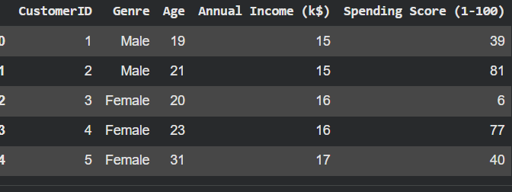
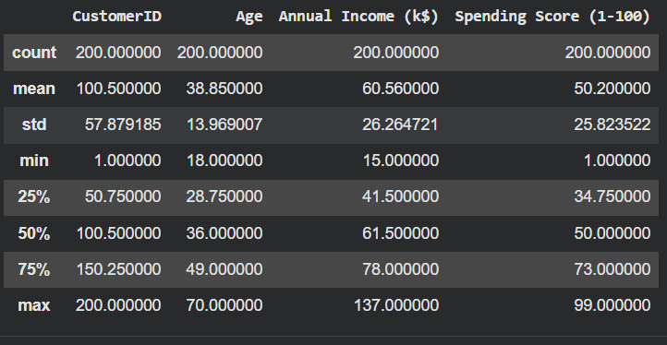
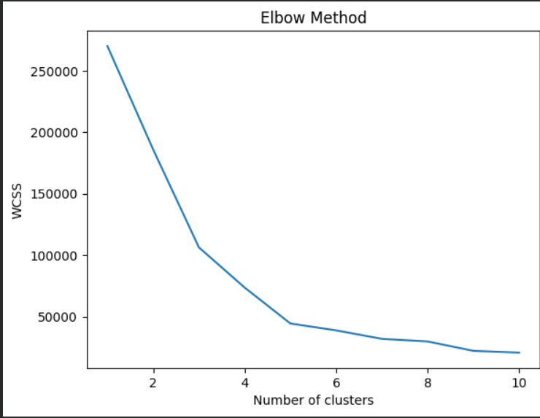
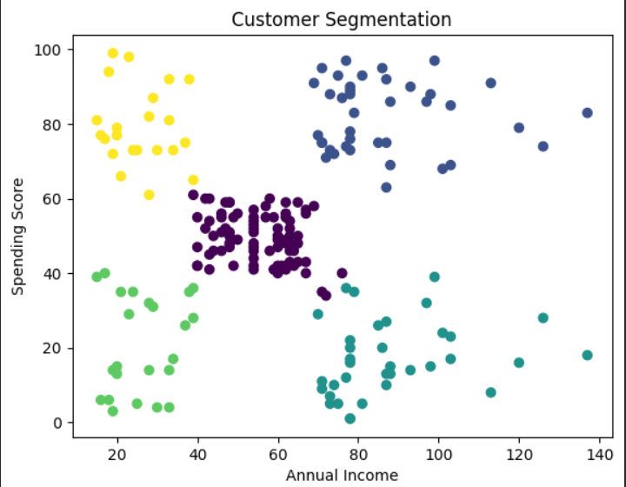

4.1 Performance Metrics

The performance of the customer segmentation system is evaluated using clustering-based metrics that measure the quality of grouping. Since clustering is an unsupervised learning technique, traditional classification metrics like accuracy are not applicable. Instead, metrics such as inertia and silhouette score are used to assess how well the model forms meaningful customer segments.
Inertia (Within-Cluster Sum of Squares)
• Measures how closely data points are grouped within a cluster
• Indicates compactness of clusters
• Lower values represent better clustering quality
Silhouette Score
• Measures how well a data point fits within its cluster
• Compares similarity within cluster vs other clusters
• Value ranges from -1 to 1 (higher is better)
Elbow Method
• Used to determine optimal number of clusters (K)
• Plots number of clusters vs inertia
• Elbow point indicates best K value
Cluster Visualization
• Scatter plots used to visualize clusters
• Different colors represent different customer groups
• Helps in understanding cluster separation clearly
- Optimal number of clusters (K = 5) ensures proper segmentation
- Lower inertia value indicates compact and well-formed clusters
- Silhouette score (~0.5) shows reasonably good separation between clusters
- Clear cluster visualization confirms meaningful grouping of customers
- Combination of metrics and graphs provides reliable evaluation of model

Cluster Interpretation
• Cluster 1: High income, high spending customers
• Cluster 2: High income, low spending customers
• Cluster 3: Low income, high spending customers
• Cluster 4: Low income, low spending customers
• Cluster 5: Average income and spending customers

Metric Table
Metric | Description | Formula | Value (Example)
Inertia | Measures compactness of clusters | Σ (distance to centroid)² | Low
Silhouette Score | Measures cluster separation | (b - a) / max(a, b) | ~0.5
Optimal K | Number of clusters | Elbow Method | 5

In conclusion, the evaluation of the customer segmentation system using clustering metrics provides a clear understanding of its effectiveness. While inertia measures how compact the clusters are, the silhouette score helps in evaluating how well-separated the clusters are.

The use of the Elbow Method ensures that the optimal number of clusters is selected, avoiding both under-segmentation and over-segmentation. Visualization techniques further support the analysis by clearly showing how customers are grouped based on their behavior.

Overall, the results demonstrate that the proposed segmentation model is effective in identifying meaningful customer groups. The system provides valuable insights into customer behavior, making it useful for business decision-making and targeted marketing strategies.

CHAPTER 5
CONCLUSION

5.1 Conclusion and Future Enhancement
The project “Customer Segmentation Using Data Warehouse and Machine Learning” has been successfully designed and implemented using data analytics and clustering techniques. The system effectively processes customer data and groups customers into meaningful segments based on their behavior and attributes such as income and spending patterns.By applying machine learning algorithms like K-Means clustering, the project demonstrates how customer data can be analyzed to identify patterns and similarities. The use of a data warehouse ensures efficient storage and management of large datasets, making the system scalable and suitable for real-world applications.
The success of the project lies in its structured approach, which includes data collection, preprocessing, feature selection, clustering, and visualization. Each stage contributes to improving the accuracy and effectiveness of the segmentation process. The results obtained show that the system is capable of identifying different types of customers, such as high-value customers, average customers, and low-spending customers.The importance of this project is significant in modern business environments, where understanding customer behavior is essential for growth. Customer segmentation helps organizations design targeted marketing strategies, improve customer engagement, and increase overall profitability. By using machine learning techniques, businesses can make data-driven decisions rather than relying on assumptions.Despite its effectiveness, the project has certain limitations. The current system works on static datasets and does not support real-time data processing. Additionally, the K-Means algorithm assumes clusters of similar shapes, which may not always reflect real-world customer behavior accurately.
Future enhancements can include integrating real-time data processing systems, such as streaming technologies, to provide instant insights. Advanced machine learning techniques like deep learning and hybrid clustering methods can also be applied to improve accuracy. Furthermore, incorporating more features such as customer demographics and transaction history can enhance the quality of segmentation.

REFERENCES

1. Research Paper: Customer Segmentation using Machine Learning
2. Research Paper: Market Segmentation Analysis using K-Means Clustering
https://www.sciencedirect.com/science/article/pii/S1877050917312824
3. Research Paper: Data Mining Techniques for Customer Segmentation
https://www.sciencedirect.com/science/article/pii/S1877050916300780
4. Machine Learning Basics – IBM
https://www.ibm.com/topics/machine-learning
5. Data Warehousing Concepts – Microsoft Learn
https://learn.microsoft.com/en-us/azure/architecture/data-guide/data-warehousing/
6. Big Data Analytics Overview – Microsoft Learn
https://learn.microsoft.com/en-us/azure/architecture/data-guide/big-data/
7. K-Means Clustering – Scikit-learn Documentation
https://scikit-learn.org/stable/modules/clustering.html#k-means
8. DBSCAN Clustering – Scikit-learn Documentation
https://scikit-learn.org/stable/modules/clustering.html#dbscan
9.Python Official Documentation
https://docs.python.org/3/
10. NumPy Documentation
https://numpy.org/doc/
11.Pandas Documentation
https://pandas.pydata.org/docs/
12.Matplotlib Documentation
https://matplotlib.org/stable/contents.html
13. Kaggle Dataset: Mall Customer Segmentation Data
https://www.kaggle.com/datasets/vjchoudhary7/customer-segmentation-tutorial
14. GitHub Link
https://github.com/geetha-487/customer-segmentation-data-mining

